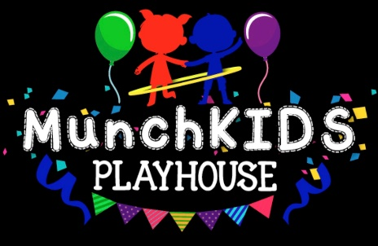

Holiday Calendar for 2020-2021

Childcare services will not be provided on the following Holidays:
Staff Development Day Wednesday, November 11, 2020
Thanksgiving Day Thursday, November 26, 2020 and Friday, November 27, 2020
Christmas Eve Thursday, December 24, 2020 hours are from 6:30am-2:30pm
Christmas Day Friday, December 25, 2020
New Year’s Eve Thursday, December 31, 2020 hours are from 6:30am-2:30pm
New Year’s Day Friday, January 1, 2021
Martin Luther King, Jr. Day Monday, January 18, 2021
President's Day Monday, February 15, 2021
Memorial Day Monday, May 31, 2021
Independence Day Monday, July 5, 2021 (in lieu)
Labor Day Monday, September 6, 2021
Columbus Day Monday, October 11, 2021
Staff Development Day Thursday November 11, 2021
Thanksgiving Day Thursday, November 25, 2021 and Friday, November 26, 2021
Christmas Eve Friday, December 24, 2021 (in Lieu)
New Year’s Eve Friday, December 31, 2021 (in Lieu)

